- UK GDP disappointed again in October, with output falling modestly for the second consecutive month. Though we think noisy monthly data is probably exaggerating the recent loss of momentum, October's weak outturn suggests quarterly growth is likely to remain relatively soft in Q4.
- We expect the economy to regain some of its momentum next year. However, restrictive fiscal policy and the lagged impact of past interest rate rises mean tight policy settings will act as powerful headwinds to activity. As a result, we expect GDP growth will be confined to trend-rates through 2025.
It's been a very quiet week, with October's GDP data being the only release of note. After a surprisingly strong performance across the first half of 2024, recent GDP releases have underwhelmed. October's data continued in that disappointing vein, with the Office for National Statistics reporting that GDP fell for the second consecutive month, albeit only by a marginal 0.1% month-on-month. This was below the consensus forecast for a 0.1% m/m rise.
Delving into the detail, the modest decline in activity was partly driven by a particularly weak reading for consumer-facing services (Chart 1). This may have reflected a degree of payback following a series of monthly gains in the sector since the summer, and the lower outturn was consistent with the month's disappointing retail sales results. The performance in the rest of the services sector was more positive, following a decent rebound in communications and another expansion in professional services. However, this was offset by contractions in manufacturing and construction.
Our takeaway from this is that the official monthly output data remains very noisy, and that this volatility has probably exaggerated both the above-trend growth rates achieved in H1 2024 as well as the subsequent loss of momentum since then. We think the underlying picture is likely more benign. Nevertheless, October's softer reading suggests quarterly growth is likely to remain relatively soft in Q4.
Chart 1: Consumer-facing services, manufacturing, and construction all weighed on GDP in October
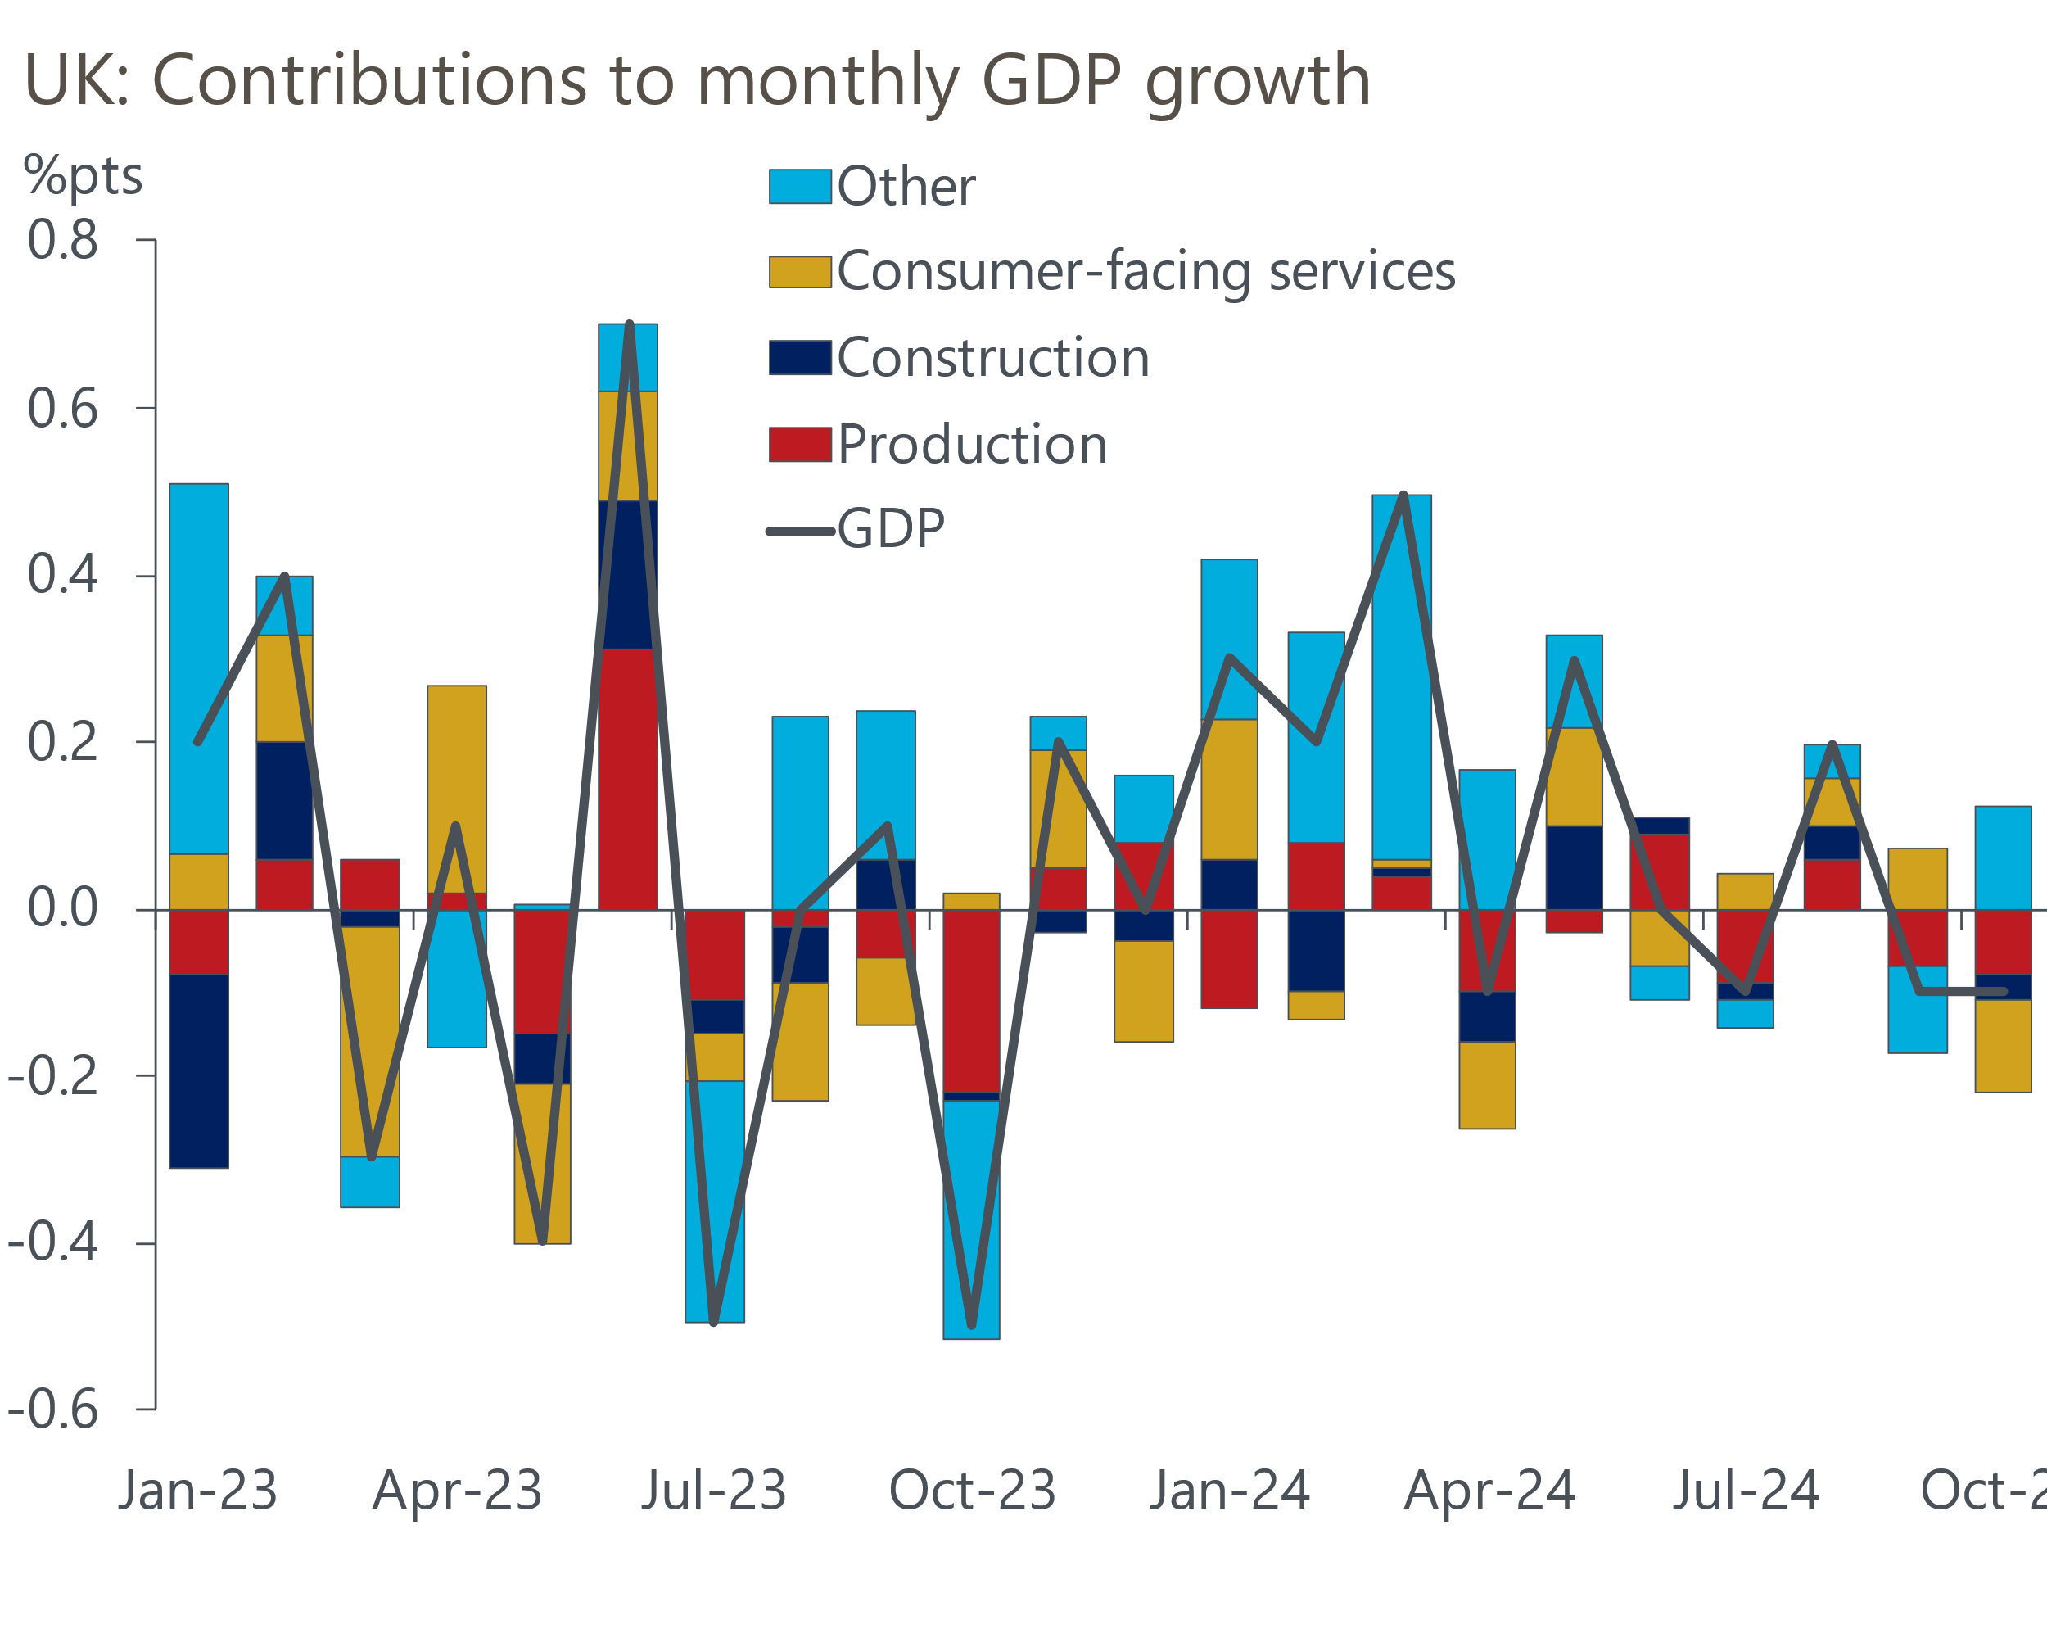
Source: Haver Analytics

Looking ahead to next year, we expect the economy to rebuild some momentum after its recent soft patch, but a scenario in which GDP grows at noticeably above-trend rates appears unlikely. As outlined in a recent Research Briefing on the key themes shaping our outlook for 2025, a key tenet of our forecast for decent but unspectacular growth is that tight policy settings will act as powerful headwinds to activity.
The Bank of England's Monetary Policy Committee is expected to continue to gradually cut Bank Rate next year. The experience of the recent hiking cycle suggests that further rate cuts should quickly passthrough to corporate interest rates, which will provide further scope for firms to borrow to invest. However, the transmission of rate cuts to the household sector will be far more protracted and the lagged impact of past rate hikes is likely to dominate. Data from the Financial Conduct Authority suggests around 1mn mortgagors will need to refinance fixed-rate deals that expire in 2025. Given many of those borrowers will be refinancing expiring five-year fixes, they face a substantial increase in monthly repayments, which will weigh heavily on disposable incomes and spending.
It's a similar story with respect to the impact of fiscal policy on growth prospects. Compared with the plans inherited from the previous government, October's budget loosened fiscal policy. However, the updated plans still build in a large fiscal tightening, therefore the government's fiscal stance will remain very restrictive through 2025 and the rest of this parliament (Chart 2).
Chart 2: Despite Budget announcements, fiscal policy will still be tightened significantly this parliament
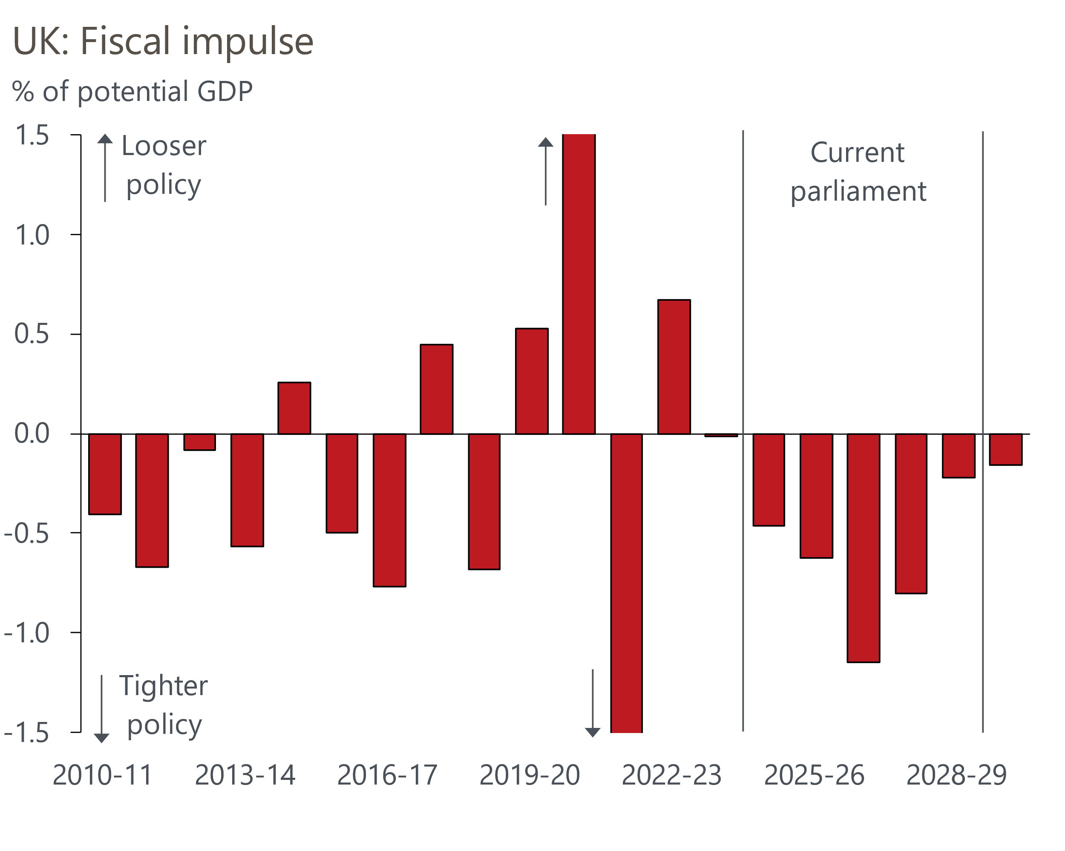
Sources: Oxford Economics, Haver Analytics
Earlier this week, the Chancellor kicked off the next phase of the government's multi-year spending review. This will require the government to turn spending totals from 2026-27 onwards into department-by-department allocations. Calculations by the Office for Budget Responsibility suggest that the totals assumed in the Budget would mean real terms spending cuts for unprotected departments. Therefore, it came as little surprise that Reeves expects government departments to find efficiency savings amounting to 5% of departmental budgets by the end of the parliament.
Our view is that efficiency savings of this scale will be very difficult to achieve in practice. Given this, the UK's poor debt dynamics, and the Chancellor's wafer-thin headroom against her fiscal rules, we think Reeves is likely to come under pressure to implement further tax hikes on businesses.
The spending review is due to conclude in June, so concerns about fiscal sustainability are unlikely to dissipate any time soon. The market is set to absorb a lot of extra gilt issuance at the medium- and long-ends, as a result of the much higher borrowing plans announced in the Budget, and the government is yet to offer detailed policies that might convince markets it can orchestrate a recovery from the UK's long-running poor productivity performance. Therefore, we suspect UK asset prices will continue to carry a high risk premium through 2025.

The week ahead
Next week's main event is the Monetary Policy Committee meeting for December. The MPC has settled into a cut-hold tempo for policy loosening and the data published in the six weeks since the November meeting is unlikely to have convinced a majority on the committee to increase the pace of rate cuts. Therefore, we anticipate an 8-1 vote to keep Bank Rate unchanged at 4.75%, with arch-dove Swati Dhingra the sole dissenter.
The pay data showed some signs that the downward momentum was levelling off in the three months to September. The pay settlement for NHS staff, which was agreed during the summer, was reflected in October's payslips. Therefore, we think there's a good chance that headline (three-month average of the annual rate) pay growth ticked up in October, with the total pay measure expected to come in at 4.7% and regular pay at 5%.
On the quantities side, we suspect the unemployment rate remained steady at 4.3% in the three months to October. But with the ONS yet to introduce key methodological changes to its flagship Labour Force Survey, we continue to see the LFS data as an unreliable indicator of conditions in the job market.
We estimate that CPI inflation rose to 2.7% in November. Base effects are likely to have played a major role, with a usually weak outturn for core goods prices last November likely to push core inflation higher. Meanwhile, weekly data from the Department of Environment and Climate Change suggests petrol prices rose by 0.8% between October and November, having fallen by 2.4% between those months last year. This means the fuel category should have exerted a slightly smaller drag on headline inflation in November.
The flash S&P Global surveys will be published a week earlier than normal because of the Christmas holidays. Recent survey readings have been much softer than earlier in the year. However, the outturns tend to be affected by swings in sentiment, and we think dissatisfaction with tax rises for businesses announced in the Budget has had a heavy bearing on recent results. We think some of the negative sentiment will have dissipated in December's survey, so we expect the flash composite PMI to edge up to 50.9.
Retail sales slumped in October, but this followed three successive m/m gains. We viewed October's outturn as being normal volatility in what is a very noisy series, and expect November's outturn to show a return to modest growth, with retail sales up by 0.1% m/m. Nevertheless, the reporting period for the retail survey finished several days before Black Friday and Cyber Monday, so the ONS is likely to make a large seasonal adjustment and the outturn will be prone to revisions. Therefore, a wide range of outcomes is possible.

Table 1: Week ahead calendar
Date | Events | Period | Measure | Unit | Previous | Forecast
Dec 16 | S&P Global manufacturing | Dec | PMI | % bal | 48.0 | 48.5
Dec 16 | S&P Global services | Dec | PMI | % bal | 50.8 | 51.1
Dec 16 | S&P Global composite | Dec | PMI | % bal | 50.5 | 50.9
Dec 17 | LFS unemployment | Aug-Oct | Rate | % | 4.3 | 4.3
Dec 17 | Average earnings (total pay) | Oct | 3m, y/y | % | 4.3 | 4.7
Dec 17 | Average earnings (regular pay) | Oct | 3m, y/y | % | 4.8 | 5.0
Dec 18 | CPI inflation | Nov | m/m | % | 0.6 | 0.1
Dec 18 | CPI inflation | Nov | y/y | % | 2.3 | 2.7
Dec 18 | RPI inflation | Nov | m/m | % | 0.5 | 0.4
Dec 18 | RPI inflation | Nov | y/y | % | 3.4 | 3.9
Dec 18 | Producer input prices | Nov | m/m | % | 0.1 | 0.0
Dec 18 | Producer input prices | Nov | y/y | % | -2.3 | -1.8
Dec 18 | Producer output prices | Nov | m/m | % | 0.0 | 0.1
Dec 18 | Producer output prices | Nov | y/y | % | -0.8 | -0.7
Dec 18 | Land Registry house prices | Oct | y/y | % | 2.9 | 3.6
Dec 19 | BoE Bank Rate decision | Dec | Bank Rate | % | 4.75 | 4.75
Dec 20 | Public finances | Nov | PSNB ex | £bn | 17.4 | 15.7
Dec 20 | Retail sales inc fuel | Nov | m/m | % | 0.7 | 0.1
Dec 20 | Retail sales inc fuel | Nov | y/y | % | 2.4 | 1.0
Source: Oxford Economics

Key forecasts
Table 2: UK forecast overview
(Annual percentage changes unless specified)
 | 2022 | 2023 | 2024 | 2025 | 2026 | 2027
GDP | 4.8 | 0.3 | 0.9 | 1.4 | 1.7 | 1.8
Private consumption | 7.3 | 0.5 | 0.8 | 1.7 | 1.5 | 1.6
Fixed investment | 5.1 | -0.1 | 1.0 | 0.8 | 3.4 | 2.5
Government consumption | 0.6 | 0.6 | 2.4 | 2.9 | 1.6 | 1.6
Exports of goods and services | 12.6 | -2.2 | -1.9 | 1.9 | 1.6 | 1.5
Imports of goods and services | 13.0 | -3.4 | 2.5 | 2.2 | 1.8 | 1.5
Industrial Production | -6.4 | -1.2 | -1.1 | 0.6 | 1.2 | 1.1
Consumer prices | 9.1 | 7.3 | 2.6 | 3.0 | 2.4 | 2.1
Unemployment rate (%) | 3.9 | 4.0 | 4.3 | 4.4 | 4.3 | 4.2
Current a/c balance (% of GDP) | -2.2 | -2.0 | -3.1 | -2.8 | -2.8 | -2.7
Government balance (% of GDP) | 4.1 | 5.0 | 4.5 | 3.7 | 2.9 | 2.2
Central bank policy rate (%, EOP) | 3.50 | 5.25 | 4.75 | 3.75 | 3.00 | 2.50
10yr govt. bond yield (%, EOP) | 3.67 | 3.54 | 4.30 | 4.16 | 3.79 | 3.41
Exchange rate (US$ per £, EOP) | 1.20 | 1.27 | 1.26 | 1.27 | 1.27 | 1.28
Exchange rate (euro per £, EOP) | 1.13 | 1.15 | 1.20 | 1.20 | 1.20 | 1.20
Source: Oxford Economics
Table 3: Quarterly forecasts for the UK
 | 2024 |  |  |  | 2025
 | Q1 | Q2 | Q3 | Q4 | Q1 | Q2 | Q3 | Q4
GDP (% year) | 0.3 | 0.7 | 1.0 | 1.7 | 1.4 | 1.3 | 1.5 | 1.5
CPI inflation (% year) | 3.5 | 2.1 | 2.1 | 2.6 | 2.8 | 2.9 | 3.3 | 2.9
Bank Rate (%, EOP) | 5.25 | 5.25 | 5.00 | 4.75 | 4.50 | 4.25 | 4.00 | 3.75
10yr gilt yield (%, EOP) | 3.95 | 4.17 | 4.00 | 4.30 | 4.28 | 4.27 | 4.23 | 4.16
US$ per £ (EOP) | 1.26 | 1.26 | 1.34 | 1.26 | 1.26 | 1.26 | 1.27 | 1.27
Euro per £ (EOP) | 1.17 | 1.18 | 1.20 | 1.20 | 1.20 | 1.20 | 1.20 | 1.20
Source: Oxford Economics

Latest Country Economic Forecast:
December 10, 2024

Recent publications

Data Insights
UK GDP falls again in October
PMI fell in November, but sentiment was likely a driving force
Manufacturing PMI slumped further below 50 in November
Mortgage approvals reached a 26-month high in October
November's PMI won't set alarm bells ringing yet

Research Briefings
MPC preview – No urgency to switch up the tempo
Why Bank Rate will fall further than markets think
Key themes 2025 – Worrying debt dynamics shift into focus
Why the energy shock persisted for firms, but may soon fade
Macro impact of Trump’s tariffs shouldn’t be overstated
MPC sticks to the cut-hold tempo

Contacts

Oxford Economics' UK team
- Andrew Goodwin - Chief UK Economist - agoodwin@oxfordeconomics.com
- Edward Allenby - UK Economist - eallenby@oxfordeconomics.com

